Power BI Instruction Report
Final Capstone Project – Housing Market Analysis Across Arizona Counties

Overview
This Power BI report analyzes socioeconomic factors influencing home values across Arizona counties. The dashboard uses a merged dataset created through Python and provides insights into income, poverty, education, commute patterns, and homeownership. The report contains five pages and a mobile layout.

Connecting to the Data
The Power BI file uses the processed dataset:
az_housing_merged.csv
To connect or update the data source:
- Open the PBIX file.
- Go to Home → Transform Data → Data Source Settings.
- Select the file path and click Change Source.
- Browse to the updated CSV location.
- Select OK → Close & Apply.

Refreshing the Data
When new data is added:
- Click Home → Refresh.
- All visuals and calculations update automatically.
- Save the PBIX to preserve changes.

Dashboard Navigation
Page 1 – Overview
Summary of KPIs including home value, income, poverty, education, and homeownership.
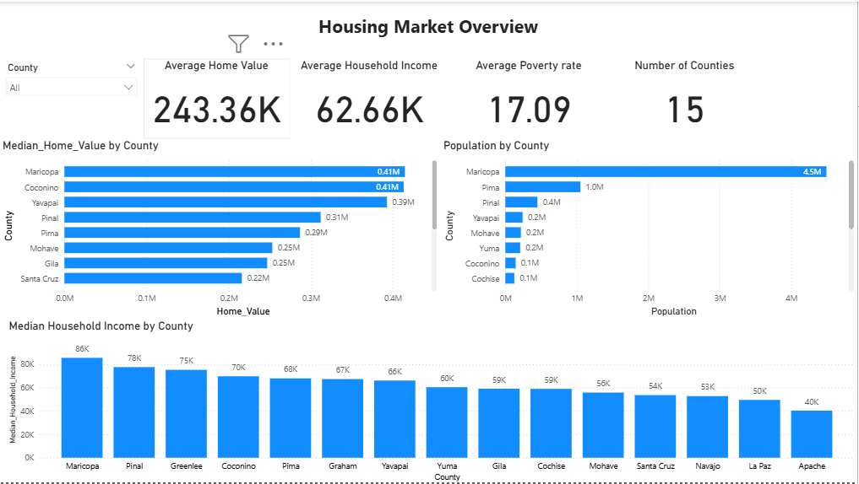
Page 2 – Income & Poverty
Scatterplots and bar charts showing correlations between income, poverty, and home value.
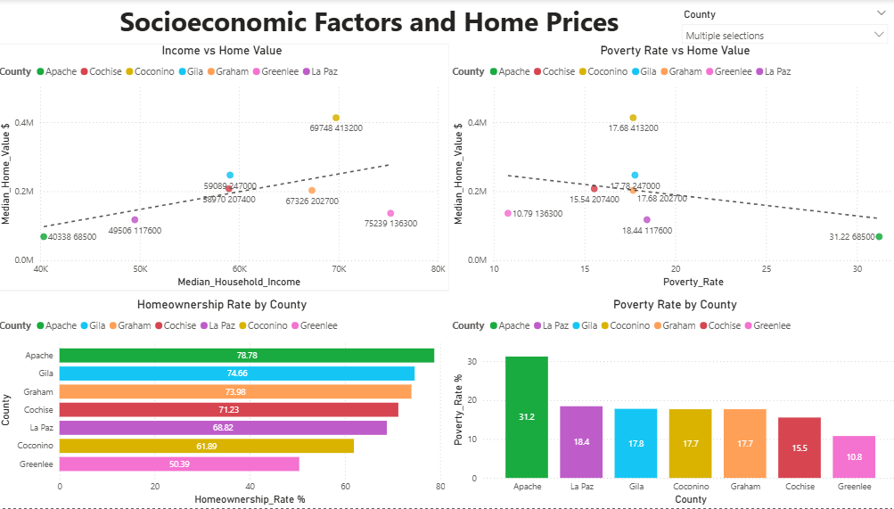
Page 3 – Education, Ownership & Commute
Visuals showing how education and commute patterns relate to home values.
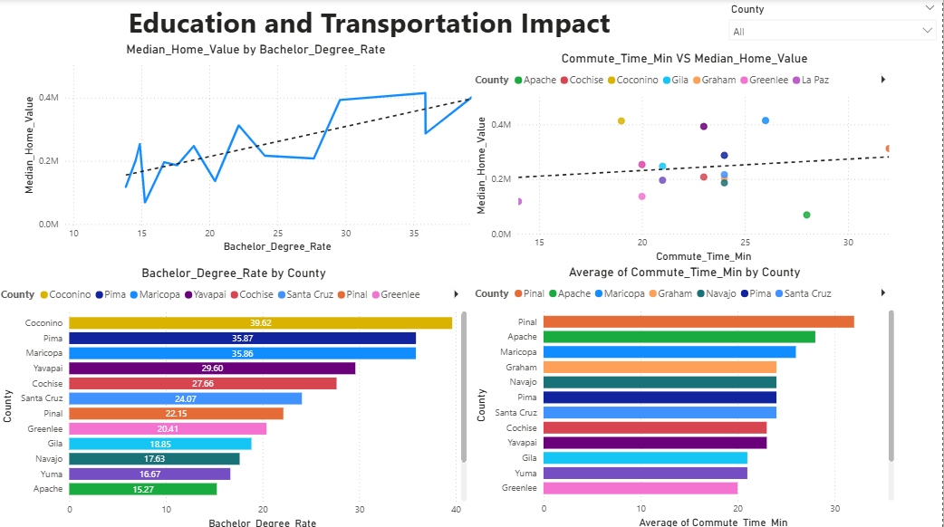
Page 4 – County Comparison
Side-by-side comparisons of counties using multiple socioeconomic indicators.
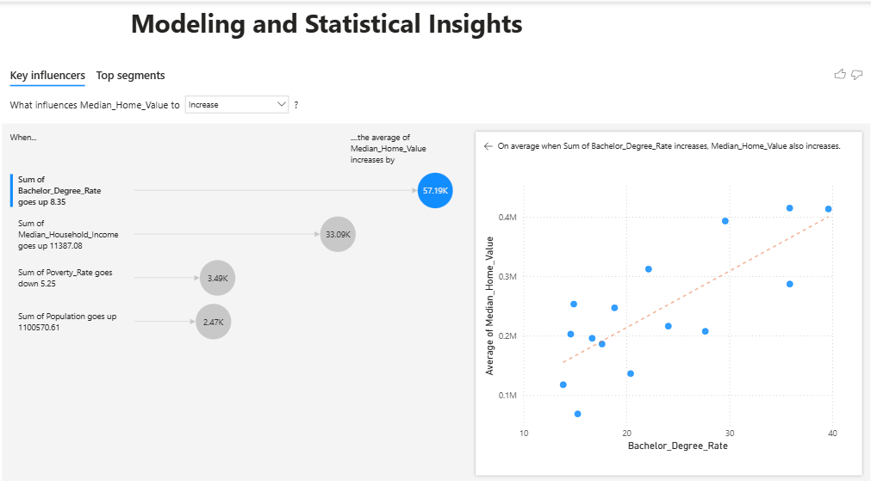
Page 5 – Mobile View
Slicer-friendly layout optimized for mobile devices.
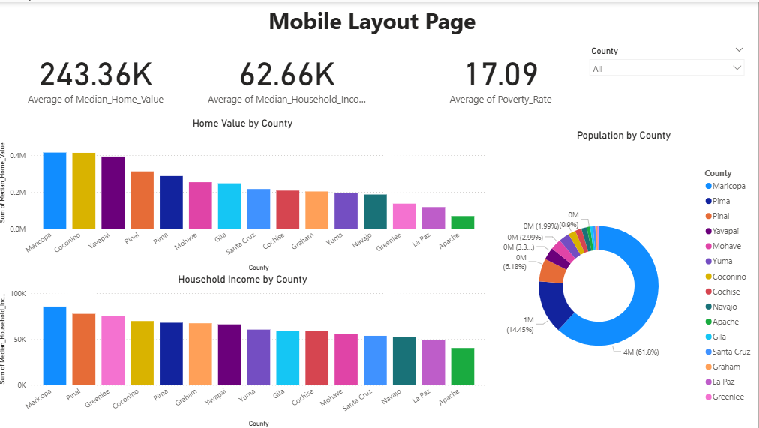

Slicer Instructions
The dashboard includes dropdown slicers for:
- County
Selecting values updates all visuals instantly.

Mobile Layout
To access the mobile-friendly page:
- Go to View → Mobile Layout in Power BI Desktop.
- The mobile page shows simplified visual arrangements designed for smaller screens.

Conclusion
This Power BI report provides a clear and interactive way to explore housing and socioeconomic trends across Arizona counties. It can be refreshed with updated data and used for decision-making, reporting, or future research.

